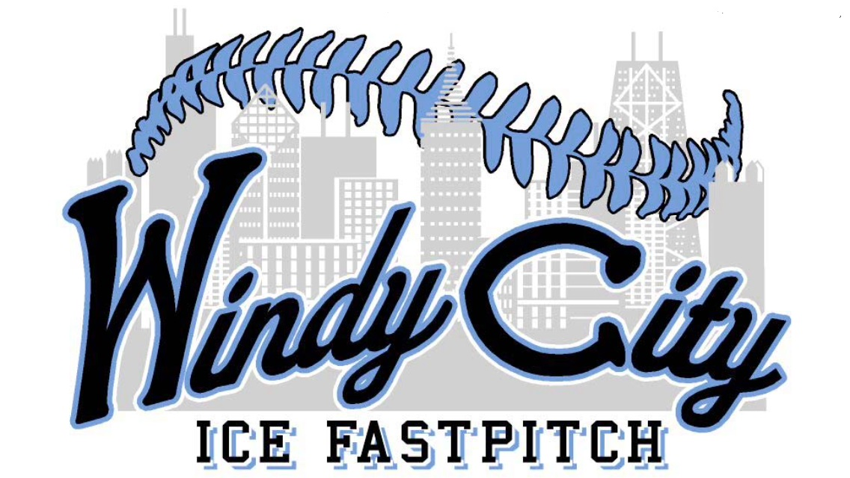**12 U Black**

**2018 Summer Schedule**

4/21/18 Spring Swing USSSA Portage Indiana

4/28/18 Children of addiction awareness USSSA Cedar Lake Indiana

5/5/18 Midwest Big B Bash 12u WSQ Kankakee Illinois

5/12/18 19th Annual Heritage Classic national qualifier 12u USSSA Joliet Illinois

5/18/18 Silver Hawks Classic USSSA St Charles Illinois

5/25/18 Mokena blast into summer qualifier USSSA Mokena Illinois

6/2/18 NSA KGSSL Classic Kankakee Illinois

6/9/18 NSA Homestead Classic Kankakee Illinois

6/15/18 USSSA State Championship Joliet Illinois

6/23/18 NSA State Rockford Illinois

6/29/18 Gameday USA Super Regional Naperville Illinois

7/16/18 12u USSSA Great Lakes National Championship Peoria Illinois