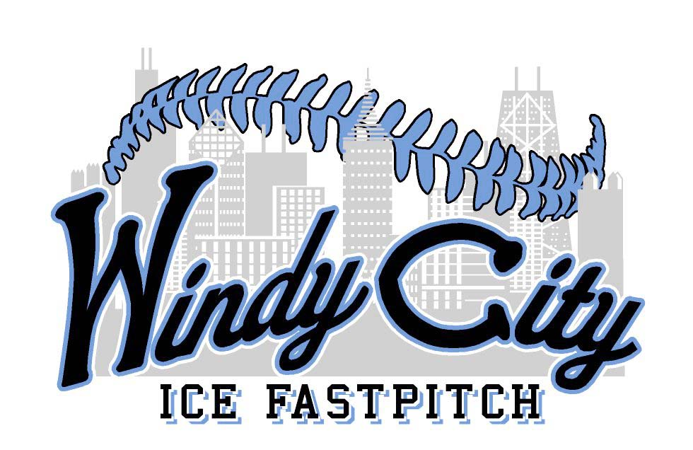
Round Robin
September 13, 2015
Format: 3 Games – 1 hr 20 min time limit
Location: Walker Park 13900 S. Laramie Ave Crestwood, IL
Cost $190

Team Name:____________________________
Age Group: 14U 16U 18U
Coaches Name:__________________________
Coaches Cell:___________________________
Email:________________________________
Please make check payable to Windy City ICE
Mail form and check to: Bill Graffeo
5434 Home Stead Dr. Crestwood IL, 60445
Please email 13billyg@att.net or call 708-829-4411 for information

